CPE301 – SPRING 2019

Design Assignment 2B

Student Name: Carlos D Zuniga

Student #: 2000783713

Student Email: zunigc2@unlv.nevada.edu

Primary Github address: https://github.com/cdaniel64/blassen/

Directory: DA2/DA2B

1. **COMPONENTS LIST AND CONNECTION BLOCK DIAGRAM w/ PINS**

Atmega328p and Hitlego Shield just like the past assignment. Diagrams are on next page.

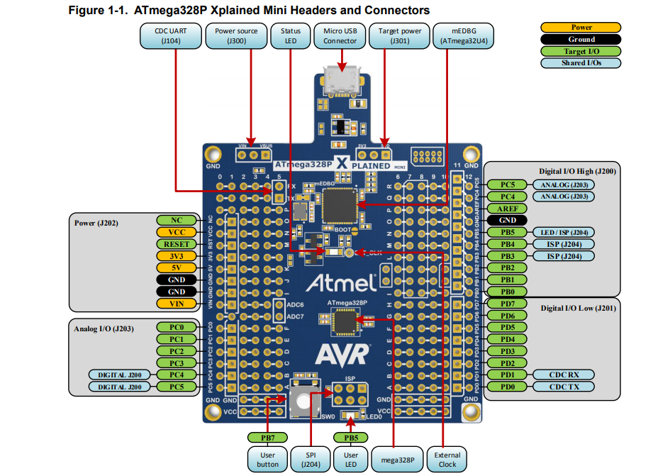 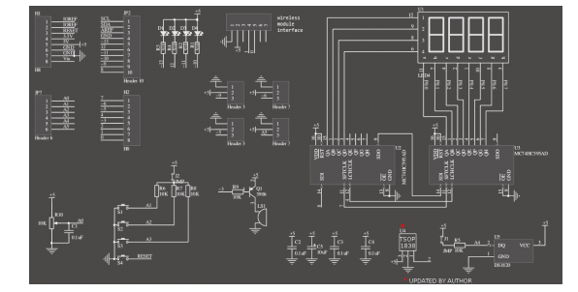

1. **INITIAL/MODIFIED/DEVELOPED CODE OF TASK 1 in Assembly**

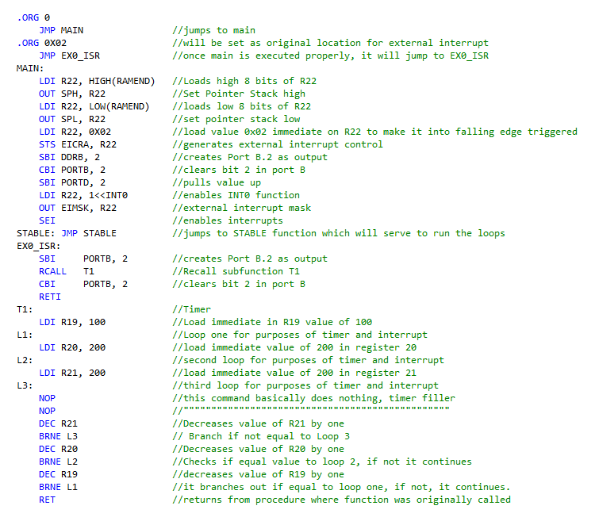

1. **INITIAL/MODIFIED/DEVELOPED CODE OF TASK 1 in C**

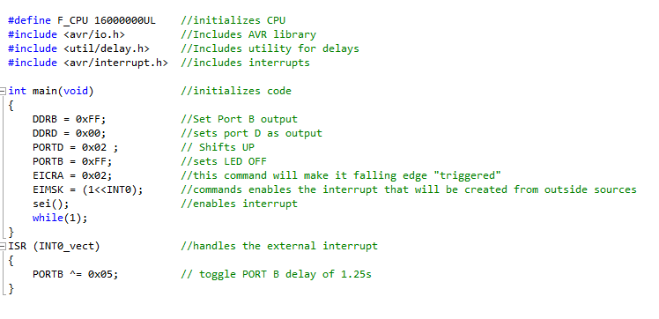

1. **SCHEMATICS**

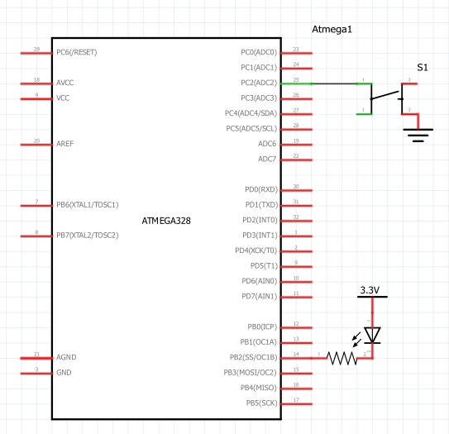

1. **SCREENSHOTS OF TASK OUTPUT**

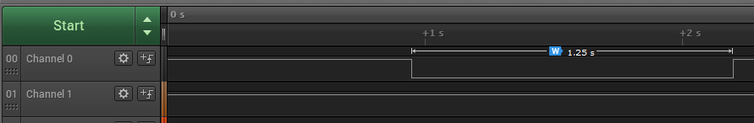

1. **VIDEO LINKS OF EACH DEMO**

**Task 1**

<https://youtu.be/31rYD_qhLq4>

1. **GITHUB LINK OF THIS DA**

<https://github.com/cdaniel64/blassen>

**Student Academic Misconduct Policy**

<http://studentconduct.unlv.edu/misconduct/policy.html>

“This assignment submission is my own, original work”